JEFFREY COPLOFF FINE ART LTD.
508 West 26th Street, Suite 318
New York, N.Y. 10001
www.jeffreycoploff.com

Tel. 212.741.1149
Fax 212.741.1189
info@jeffreycoploff.com

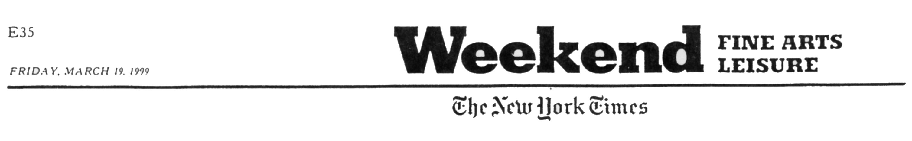

KATHLEEN KUCKA, Jeffrey Coploff, 526
West 26th Street, (212) 741-1149 (through
April 3). Physically appealing abstractions
made by a complex process of pouring and
layering. Restricting her palette to whites,
browns, blacks and grays, Ms. Kucka creates
allover, irregular patterns of concentric
whorls suggestive of wood grain or enlarged
fingerprints and punctuates each panel by
drilling a few exactly placed holes (Johnson).

